  - GUIDE

Running Breadboard Experiments on Prolific




Last Updated: July 2024

Table of Contents
Introduction 3
Setting Up Breadboard 3
Setting Up Prolific 6
Completion Paths Set Up 8
Revolution Game Completion Codes Example 9
Running the Experiment 10
Terminal/Command Prompt Logs 10
Breadboard Console 10
Prolific 11
Testing Experiments on Breadboard 14
Testing with AI 14
Testing with Breadboard’s Testing Dialog 14
Conclusion 15

Introduction

This is a guide that explains how to set up and run experiments you create on Breadboard through Prolific, a platform that recruits users online to participate in research studies. Examples shown in this guide are specific to a revolutions study, and some steps may vary depending on the structure of your study.

Setting Up Breadboard

- Go to the URL of your breadboard game and login with your credentials
  - URL (may look something like this: https://[BREADBOARD_GAME_NAME ].brdbrd.net)
  - Username
  - Password
Example:
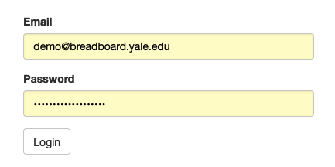

Clicking login should take you to breadboard’s console:

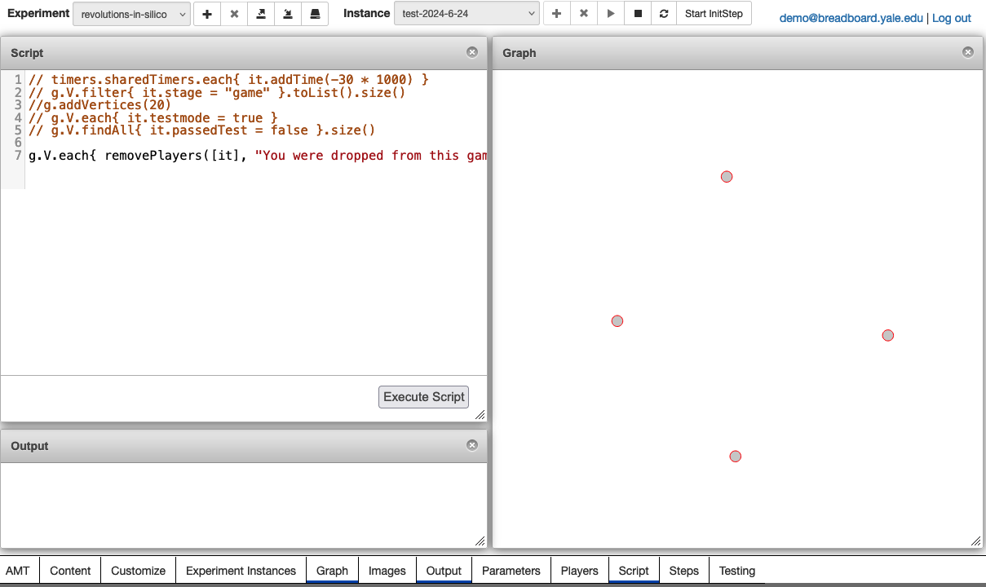

- Make sure the experiment name is correct. Create a new experiment instance.
  - *Note: It’s recommended that whatever you name the instance matches with the internal study name that you will enter later on when setting up prolific.
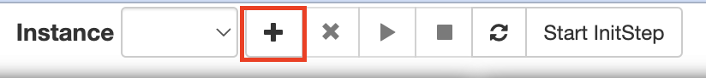

- Click Steps dialog at the bottom. In the Globals step, make sure you set the DEV and SANDBOX variables to false. This may not apply to all experiments.

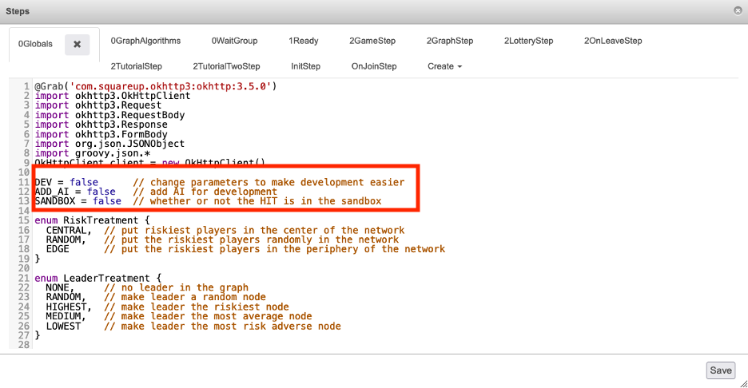

- This step may not apply to all experiments. Make sure the parameters in your study are correct (this can be changed in Globals step where Parameters are defined). If your study has multiple treatment types, make sure you change this in the steps dialog, save your changes (click Save on the bottom right), and reload the script engine (refresh button in the top right).

For example, in the revolution game, we would change the risk and leader treatments here:

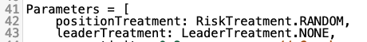

Click Save at the bottom right when done. Reload the script engine at the top. You may have to refresh your page if it is loading for a while.

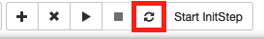

- SSH into the breadboard server through terminal/command prompt to view the experiment’s logs using the following commands (the commands may vary slightly depending on your study):
ssh -p 2341 revolution@brdbrd.net
cd revolution-v2.4
tail -f nohup.out

Your terminal should look something like this after you run the commands:
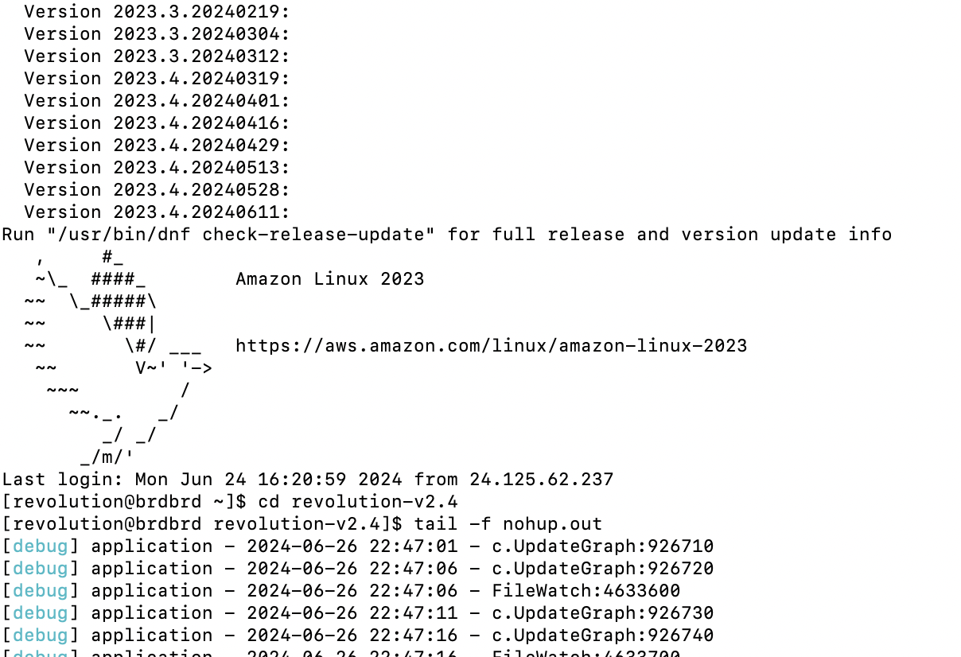
Everything should be set up on the breadboard end now. You can now proceed to Prolific.

Setting Up Prolific
- Select your project and create a new study. If an instance of your study already exists, you can click on the study and then duplicate it.

Create a new study:
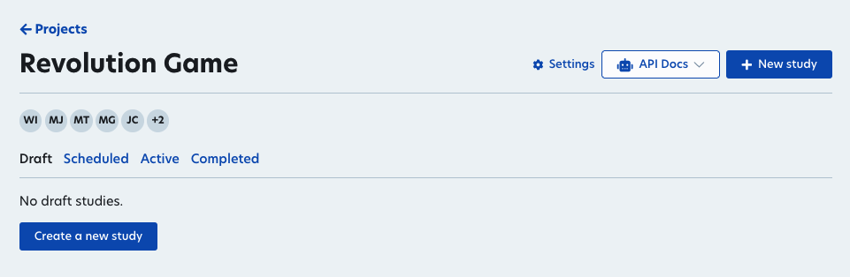

Duplicate a study:
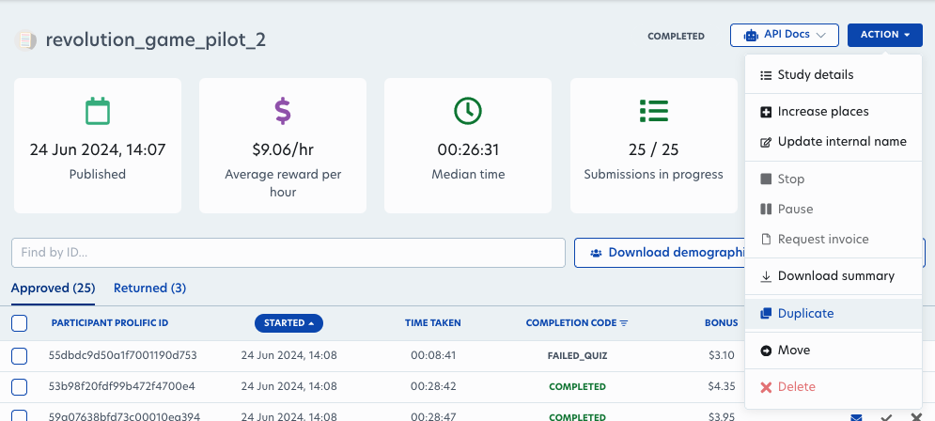

- On the Set up your study, fill in the fields based on what your study needs. It’s recommended that your Internal study name matches the instance name you created in breadboard for consistency.
- Under How do you want to collect your data?, copy this URL and change the bolded numbers below to match the client URL of your breadboard instance
  - https://rvl.brdbrd.net/game/393/773/prolific?PROLIFIC_PID={{%PROLIFIC_PID%}}&STUDY_ID={{%STUDY_ID%}}&SESSION_ID={{%SESSION_ID%}}

Prolific:
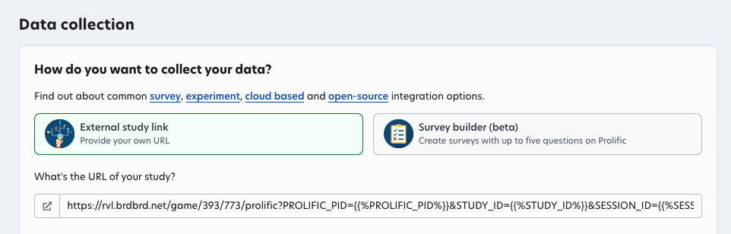
Breadboard console (ignore status STOPPED, your instance should be running):
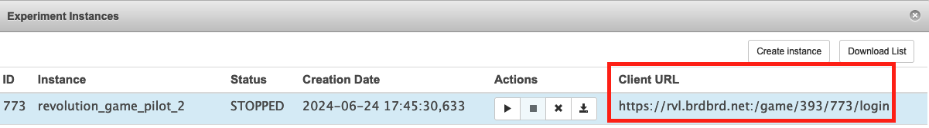
- Under Prescreen participants, you probably want to exclude the participants from any other instances of your studies. (This will auto populate if you duplicate previous study instances)

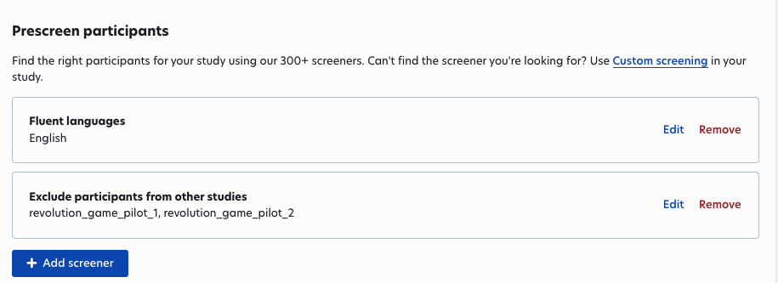

**NOTE: Any prescreeners you add will be downloadable through Prolific’s demographic data (explained later). When you click add screener, you can choose from many preset questions and filter out the participants who choose certain answers (or select them all). This is Prolific’s recommended way of collecting demographic data. Prolific also recommends that you validate the prescreener questions in the beginning of your study, so that you can return any participants should they answer inconsistently with their prescreener answer. If you choose to do this, you must word the questions in your study the EXACT way it’s worded in the prescreener.

- Make sure the rest of the fields match want you want for the study. You can click Preview as participant at the bottom to make sure everything looks right. Then you can click Publish now to publish the experiment. Once you publish the experiment, participants can start joining.

This concludes the Prolific set up.

Completion Paths Set Up
When participants finish your study, they need to enter a completion code on Prolific to show that they've completed your study. A completion code can specify different conditions under which they exited the game. For example, here is a completion path from the revolution game:

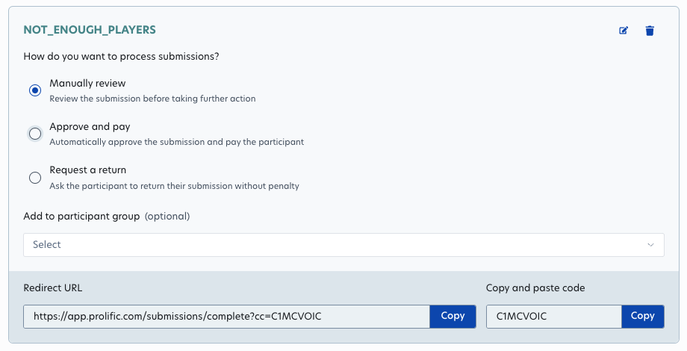
In the revolution game, we require at least 15 players in order for the experiment to proceed. In the completion path above, players will be kicked out of the game if there are not enough players with the “C1MCVOIC” code. When you download the Breadboard experiment instance data (explained in the Running the Experiment section), you can check which completion code a player exited with, and match that to the participant on Prolific with their player id. In the revolution game, players are paid different bonuses depending on their completion code. In your experiment, you may have a different use case for completion codes (but it tends to be helpful to have more of them to better explain what caused a player to leave).
Here is an example of a set of completion codes that we used in the revolution game. We had two possible bonus payments—one from our lottery round and one from our actual revolution game.

Revolution Game Completion Codes Example

Completion Code Name | Prolific Code | Description | Bonus
COMPLETE | C1MTZON7 | Players who completed all rounds of the experiment successfully | Base pay + both bonuses
FAILED_LOTTERY | C1HY3M7Y | Players who demonstrated irrational behavior in the lottery. Irrational behavior is defined as picking the option that has a 0% chance of payment in the first or last lottery choice or when the number of swaps between the choices exceeds 3. | Base pay + lottery bonus
FAILED_QUIZ | CLYTL771 | Players who failed the comprehension quiz at the end of the tutorial (missed more than two questions after two attempts). | Base pay + lottery bonus
PLAYER_IDLE | C8NGXRRJ | Players who were idle for too long during the game (i.e. didn’t make a choice within the allotted time). | Base pay + lottery bonus
NOT_READY | CTQFLWV0 | Players who did not click the ready button within the allotted time after the 20-minute timer for the tutorial ended. | Base pay + lottery bonus
DIDN’T_COMPLETE_TUTORIAL | CO0HI6W4 | Players who did not complete the tutorial within 20 minutes. | Unpaid
NOT_ENOUGH_PLAYERS | C1MCVOIC | If the number of ready players is not at least 15 by the time the game is supposed to start, all the ready players are dropped with this code. | Base pay + lottery bonus
TOO_MANY_PLAYERS | C7HOJMLQ | If the number of ready players exceeds 25 by the time the game is supposed to start, some random players will be dropped with this code to get the number of players down to 25. | Base pay + lottery bonus
FAILED_CAPTCHA | C18LDTAB | Players who fail the captcha | Unpaid
GAME_STARTED | CQ4P9QVU | Players who join when the game has already started (should not happen if Prolific study is paused before the game starts). | Unpaid

Running the Experiment
When running the experiment, there will be three primary screens to monitor: prolific, breadboard console, and terminal logs.

Terminal/Command Prompt Logs
In terminal/command prompt, you can see when participants join, the actions they take, and other data in real time.

Breadboard Console
- In the console, you can see the nodes representing each player and the choices they select each round. This is shown visually in the Graph dialog. To view a specific player, click the Players dialog at the bottom. You can filter the player data like below to see how many players are at a certain stage in the game (you can also filter by other parameters).
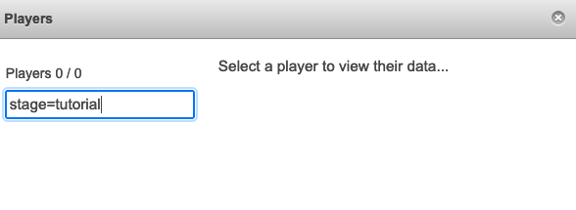
**Specific to the revolution game: If you would like to remove a player, you can run the kickPlayers(“Player ID”) function in the script.
- Once the experiment is done, you can download the data/logs from the game by clicking the download button by your experiment instance.

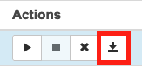

- The experiment data is formatted as csv file where each line is an event. Events and their data are grouped together by id (*Note: the ids do not necessarily increment in numerical order, so if you want to sort by the order of events, it is better to sort by event_date instead)

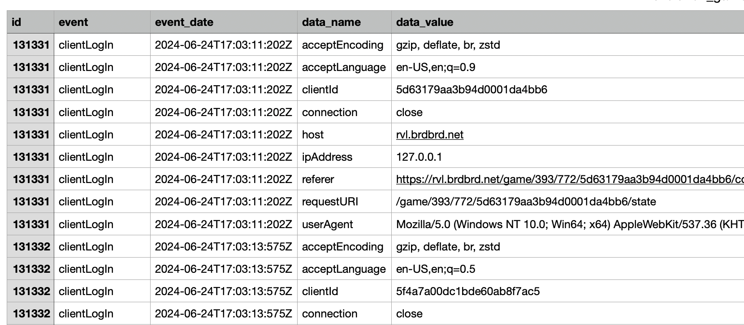

Prolific
- On Prolific, you should be able to see the number of participants, their IDs, and other data like time taken or completion codes. Once you have enough participants, you should pause the experiment by clicking Action > Pause at the top right. You can click Action > Stop when the study is complete.
- When the study is complete, you can go through the participants that still need approval and approve them. To approve them all, you can select all and click Approve selected at the bottom left.
- Once participants are approved, you can assign the bonuses. To do this you can click Bulk actions at the top right and then Bulk bonus payment.

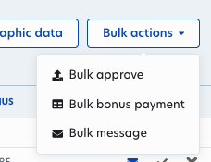

It will ask for the bonus payments in the following format: “Participant ID,bonus amount”.

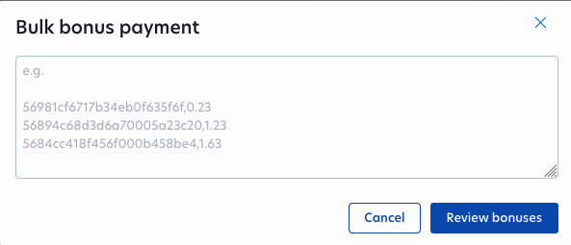

You can run the following python script with the csv file downloaded from Breadboard Console: Step 2 to automatically output the bulk bonus payment in the above format. *Make sure you change the file name where experiment_data is defined. The script will output the correctly formatted payments in bulk_bonus_payment.csv, and the payments with the exit types in metadata_bonus.csv just for your reference. It will also print the total bonus.
"""
Script to format bulk bonus payments for players on prolific from breadboard data
"""

import pandas as pd

# Function to extract player, bonus, and exit type from grouped rows
def get_id_bonus(group):
player_number = None
bonus_amount = None
exit_type = None

for _, row in group.iterrows():
if row['data_name'] == 'player':
player_number = row['data_value']
elif row['data_name'] == 'bonus':
bonus_amount = float(row['data_value']) / 100
elif row['data_name'] == 'exitType':
exit_type = row['data_value']

if player_number is not None and bonus_amount is not None:
return pd.Series([player_number, bonus_amount, exit_type], index=['player_number', 'bonus_amount', 'exit_type'])

# Read in the experiment data and select rows that have removed player and bonus
# REPLACE 'revolutions-sample.csv' WITH ACTUAL INPUT FILE
experiment_data = pd.read_csv('revolutions-sample.csv')

# Filter for 'removedPlayer' events
removed_players = experiment_data.loc[(experiment_data['event'] == "removedPlayer")]

# Group by 'id' and apply the function to extract player number and bonus
grouped = removed_players.groupby('id').apply(get_id_bonus)

# Drop any rows with None values if necessary
grouped = grouped.dropna()

# Keep track of players that have been outputted already to prevent duplicates
outputted_players = []

# Total bonus
total_bonus = 0

# Write player id and bonuses to csv file
# Write player id, bonuses, and exit type to another file
out_file = open('bulk_bonus_payment.csv', 'w')
out_file_metadata = open('metadata_bonus.csv', 'w')
for index in grouped.index:
player_id = grouped['player_number'][index]
bonus = grouped['bonus_amount'][index]
exit_type = grouped['exit_type'][index]
if player_id not in outputted_players:
total_bonus += bonus
if bonus != 0:
out_file.write(f"{player_id},{bonus:.2f}\n")
out_file_metadata.write(f"{player_id},{bonus:.2f}, {exit_type}\n")
outputted_players.append(player_id)

print(total_bonus)

- Clicking Review bonuses will show you the total amount that will be charged (including service fees, so it will be more than the total bonus calculated by the script). Once you confirm, the participants will be paid.
- Any messages you receive from the participants will also show up in the Messages tab on Prolific, but only for the person who started running the experiment.

Testing Experiments on Breadboard
If you would like to test your breadboard experiments before running them on Prolific, you have two options for testing.

Testing with AI
You can use the following command in the script dialog:
g.addAI(a, n, [behavior])
Then you can define your own behavior for the vertices. Here is an example from the breadboard documentation website:
def aiBehavior = { ai->
// Sanity check to make sure the AI actually has choices to make
if (ai.getProperty("choices")) {
// A random delay is a good idea to make the AI
// appear more human and to avoid potential race conditions
def randomDelay = 1000 + r.nextInt(3000)
new Timer().runAfter(randomDelay) {
def choices = ai.getProperty("choices")
// Choose a random choice
def choice = choices[r.nextInt(choices.size())]
a.choose(choice.uid)
}
}
}
// Add 20 AI players using the defined behavior
g.addAI(a, 20, aiBehavior)

Testing with Breadboard’s Testing Dialog
You can also create multiple vertices and manually go through the experiment from the participant’s perspective by using these two commands in the script dialog:
g.addVertices(5)
g.V.each{ it.testmode = true }
The first statement adds five vertices (participants) to the graph. The second command puts the vertices all into test mode. Once you execute these commands in the script dialog, you can open the testing dialog to see the screens of the participants:
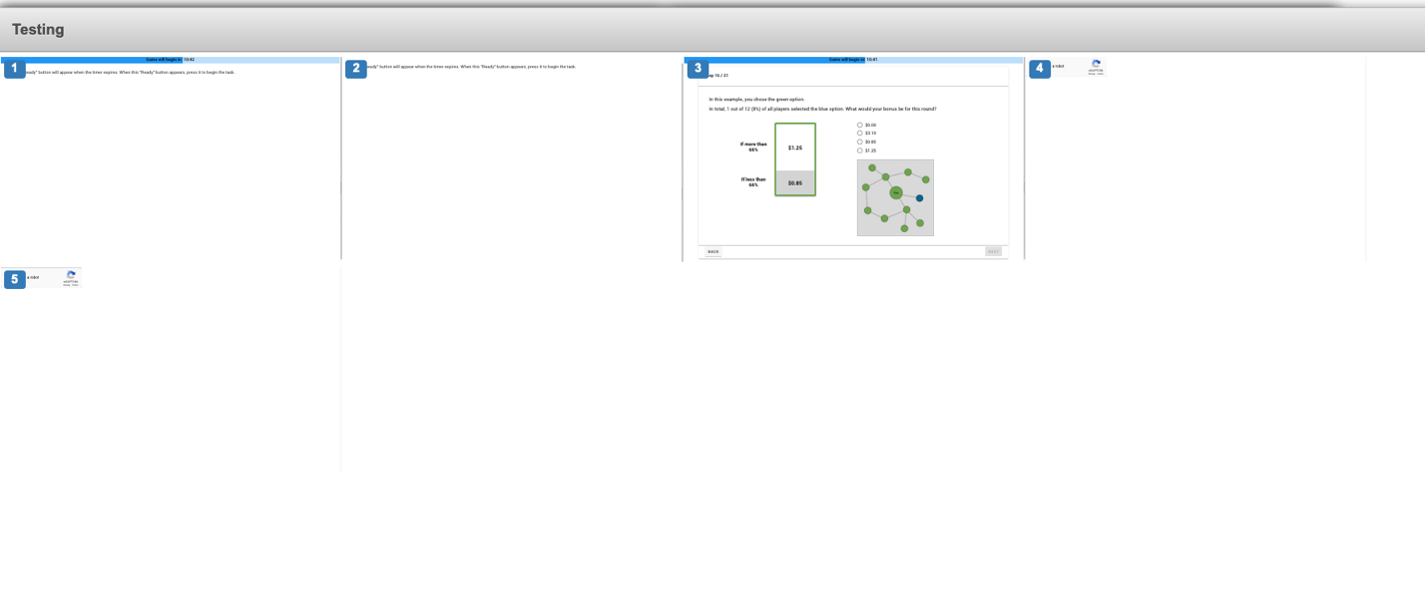
The screens are small but you can use Cmd/Ctrl and + to zoom in. Alternatively, you can also click on the client URL by the experiment instance and login using different participant IDs (can be anything as long as they are different from one another) on different tabs. This will allow you to navigate the participant screens in a larger view rather than through the Breadboard testing dialog.
For some games, if there is a DEV variable in the Globals step, you can set it to true, then click the “Start Init Step” button in Breadboard in order to move players from the ready step to the game.

Conclusion
That concludes the guide for running Breadboard experiments on Prolific. Happy experimenting!

